When establishing infrastructure on the AWS cloud, Identity and Access Management (IAM) is among the first and most critical services to configure. IAM facilitates the creation and management of user accounts, groups, roles, policies, and other access controls. The Nautilus DevOps team is currently in the process of configuring these resources and has outlined the following requirements.
Create an IAM policy named iampolicy_javed in us-east-1 region, it must allow read-only access to the EC2 console, i.e this policy must allow users to view all instances, AMIs, and snapshots in the Amazon EC2 console.

Use below given AWS Credentials: (You can run the showcreds command on aws-client host to retrieve these credentials)
Console URL | https://460059030778.signin.aws.amazon.com/console?region=us-east-1
Username | kk_labs_user_239816
Password | 5buSAknhVQsC
Start Time | Wed Dec 17 04:24:07 UTC 2025
End Time | Wed Dec 17 05:24:07 UTC 2025
Notes:
- Create the resources only in us-east-1 region.
- To display or hide the terminal of the AWS client machine, you can use the expand toggle button as shown below:
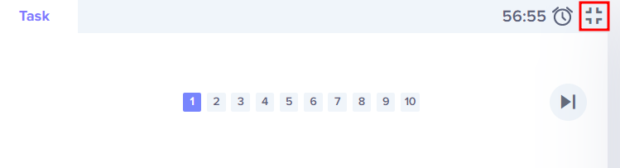

Solutions:-

🛠 Steps to Create IAM Policy
- Log in to AWS Console
  - Use the provided console URL.
  - Enter:
    - Username: kk_labs_user_239816
    - Password: 5buSAknhVQsC
- Navigate to IAM
  - In the AWS Management Console, go to IAM service.
- Create Policy
  - Click Policies → Create policy.
  - Switch to the JSON tab.
  - Paste the following JSON:
json
{
"Version": "2012-10-17",
"Statement": [
{
"Effect": "Allow",
"Action": [
"ec2:DescribeInstances",
"ec2:DescribeImages",
"ec2:DescribeSnapshots"
],
"Resource": "*"
}
]
}
- Name & Review
  - Click Next: Tags (optional).
  - Click Next: Review.
  - Enter Policy name: iampolicy_javed.
  - Ensure region is us-east-1 (your console URL already locks you there).
  - Click Create policy.

✅ Verification
- Go back to Policies list in IAM.
- Search for iampolicy_javed.
- Confirm it shows Allow for EC2 Describe* actions.

